**Lab 01**

**Software Construction**

**DOM manipulation**

**Submitted by**

Hassaan Ali Mehmood

BESE 9A

264947

**Task1**

**Code**

|  |
| --- |
| document.querySelector('.btn-roll').addEventListener('click', **function**(){  //1.random number  **var** dice = Math.floor(Math.random() * **6**) +**1**;  console.log(dice);  //2.display the result  **var** diceDOM = document.querySelector('.dice');  diceDOM.style.display = 'block';  diceDOM.src = 'dice-' + dice + '.png';  //3. update the round score IF the rolled number is not a 1  **if**(dice !== **1**){  //add score  roundScore += dice;    document.querySelector('#current-' + activePlayer).textContent = roundScore;  //document.getElementById('current-'+ activePlayer).textContent = roundScore;  array[i]=dice;  console.log(array)  i = i +**1** ;  **if** (dice == **6** && array[i-**2**] == **6** ) {  nextPlayer();  }  } **else** {  nextPlayer();  }  }); |

**Screenshot**

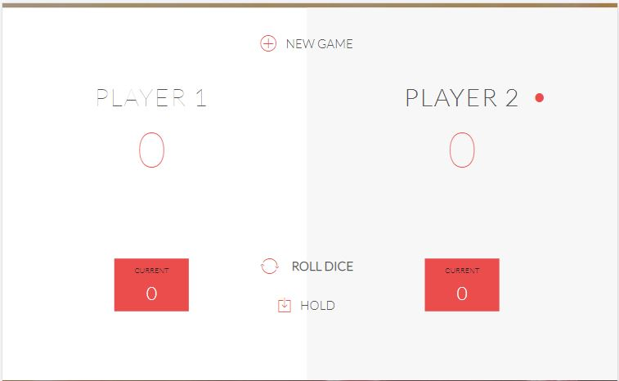

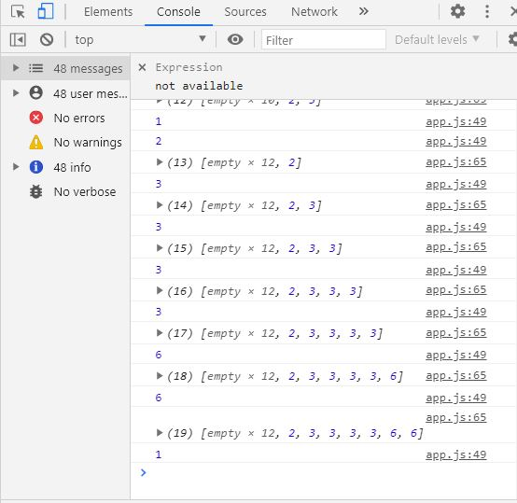

**Task2**

**Code**

|  |
| --- |
| document.querySelector('.btn-hold').addEventListener('click',**function**(){  //add current score to global score  scores[activePlayer] += roundScore;  //update the UI  document.querySelector('#score-'+ activePlayer).textContent = scores[activePlayer];  **var** input = document.querySelector('.final-score').value;  **var** winningScore;  **if**(input) {  winningScore = input;    } **else** {  winningScore = **100**;  }  //check if player won the game  **if**(scores[activePlayer] >= winningScore){  document.querySelector('#name-' + activePlayer).textContent = 'Winner!';  document.querySelector('.dice').style.display = 'none';  document.querySelector('.player-' + activePlayer + '-panel').classList.add('winner');  document.querySelector('.player-' + activePlayer + '-panel').classList.remove('active');  }  **else**{  //nextPlayer  nextPlayer();  }  }); |

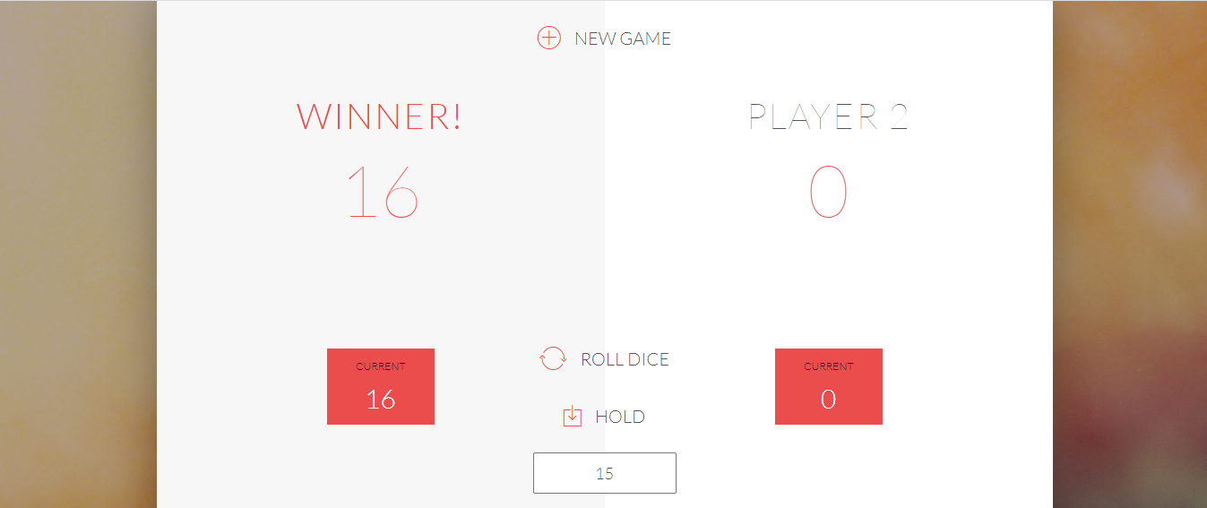

**Task3**

**Code**

|  |
| --- |
| document.querySelector('.btn-roll').addEventListener('click', **function**(){  //1.random number  **var** dice = Math.floor(Math.random() * **6**) +**1**;  **var** dice2 = Math.floor(Math.random() * **6**) + **1**;  console.log(dice);  //2.display the result  **var** diceDOM = document.querySelector('.dice');  diceDOM.style.display = 'block';  diceDOM.src = 'dice-' + dice + '.png';  document.getElementById('dice-2').style.display = 'block';  document.getElementById('dice-2').src = 'dice-' + dice2 + '.png';  //3. update the round score IF the rolled number is not a 1  **if**(dice !== **1** && dice2 !== **1**){  //add score  roundScore += dice+ dice2;    document.querySelector('#current-' + activePlayer).textContent = roundScore;  //document.getElementById('current-'+ activePlayer).textContent = roundScore;  array1[i]=dice;  array2[i]=dice2;  console.log(array1);  console.log(array2);  i = i +**1** ;  **if** (dice == **6** && array1[i-**2**] == **6** ) {  nextPlayer();  }  } **else** {  nextPlayer();  }  }); |

**Screenshot**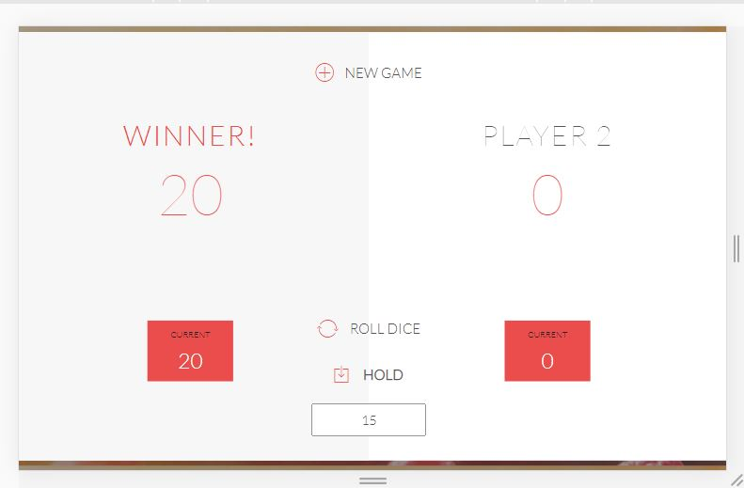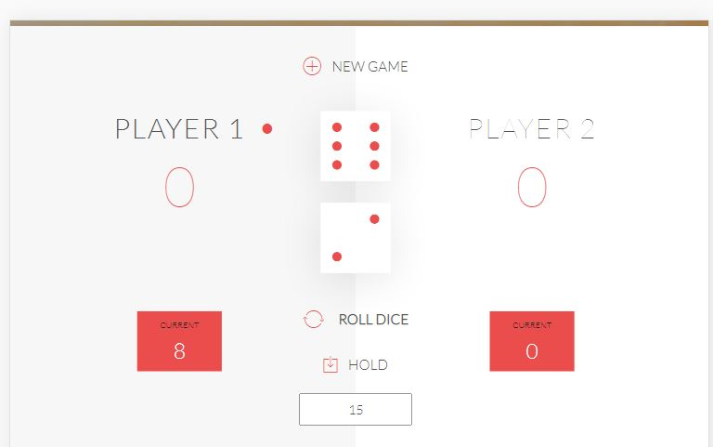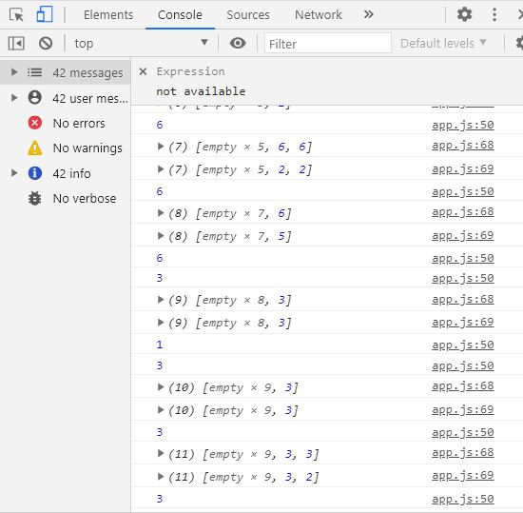

**Complete Code**

**JAVASCRIPT**

|  |
| --- |
| **var** scores, roundScore, activePlayer,gamePlaying,array1,array2,i;  start_new();  document.querySelector('.dice').style.display = 'none';  document.getElementById('score-0').textContent = '0';document.getElementById('score-1').textContent = '0';document.getElementById('current-0').textContent = '0';document.getElementById('current-1').textContent = '0';  **function** btn(){  //do something  }  btn();  //Event listenerdocument.querySelector('.btn-roll').addEventListener('click', **function**(){  //1.random number  **var** dice = Math.floor(Math.random() * **6**) +**1**;  **var** dice2 = Math.floor(Math.random() * **6**) + **1**;  console.log(dice);  //2.display the result  **var** diceDOM = document.querySelector('.dice');  diceDOM.style.display = 'block';  diceDOM.src = 'dice-' + dice + '.png';  document.getElementById('dice-2').style.display = 'block';  document.getElementById('dice-2').src = 'dice-' + dice2 + '.png';  //3. update the round score IF the rolled number is not a 1  **if**(dice !== **1** && dice2 !== **1**){  //add score  roundScore += dice+ dice2;    document.querySelector('#current-' + activePlayer).textContent = roundScore;  //document.getElementById('current-'+ activePlayer).textContent = roundScore;  array1[i]=dice;  array2[i]=dice2;  console.log(array1);  console.log(array2);  i = i +**1** ;  **if** (dice == **6** && array1[i-**2**] == **6** ) {  nextPlayer();  }  } **else** {  nextPlayer();  }  });  document.querySelector('.btn-hold').addEventListener('click',**function**(){  //add current score to global score  scores[activePlayer] += roundScore;  //update the UI  document.querySelector('#score-'+ activePlayer).textContent = scores[activePlayer];  **var** input = document.querySelector('.final-score').value;  **var** winningScore;  **if**(input) {  winningScore = input;    } **else** {  winningScore = **100**;  }    //check if player won the game  **if** (scores[activePlayer] >= winningScore) {  document.querySelector('#name-' + activePlayer).textContent = 'Winner!';  document.getElementById('dice-1').style.display = 'none';  document.getElementById('dice-2').style.display = 'none';  document.querySelector('.player-' + activePlayer + '-panel').classList.add('winner');  document.querySelector('.player-' + activePlayer + '-panel').classList.remove('active');  gamePlaying = **false**;  }  **else**{  //nextPlayer  nextPlayer();  }  });  **function** nextPlayer(){  activePlayer === **0** ? activePlayer = **1** : activePlayer = **0**;  roundScore = **0**;  document.getElementById('current-0').textContent = '0';  document.getElementById('current-1').textContent = '0';  document.querySelector('.player-0-panel').classList.toggle('active');  document.querySelector('.player-1-panel').classList.toggle('active');  document.getElementById('dice-1').style.display = 'none';  document.getElementById('dice-2').style.display = 'none';  array1 = [];  array2 = [];  }  document.querySelector('.btn-new').addEventListener('click', start_new);  **function** start_new() {  scores = [**0**, **0**];  activePlayer = **0**;  roundScore = **0**;  gamePlaying = **true**;  document.getElementById('dice-1').style.display = 'none';  document.getElementById('dice-2').style.display = 'none';  document.getElementById('score-0').textContent = '0';  document.getElementById('score-1').textContent = '0';  document.getElementById('current-0').textContent = '0';  document.getElementById('current-1').textContent = '0';  document.getElementById('name-0').textContent = 'Player 1';  document.getElementById('name-1').textContent = 'Player 2';  document.querySelector('.player-0-panel').classList.remove('winner');  document.querySelector('.player-1-panel').classList.remove('winner');  document.querySelector('.player-0-panel').classList.remove('active');  document.querySelector('.player-1-panel').classList.remove('active');  document.querySelector('.player-0-panel').classList.add('active');  i = **0**;  array1 = [];  array2 = [];  } |

**HTML**

|  |
| --- |
| <!DOCTYPE html><html lang="en">  <head>  <meta charset="UTF-8">  <link href="https://fonts.googleapis.com/css?family=Lato:100,300,600" rel="stylesheet" type="text/css">  <link href="http://code.ionicframework.com/ionicons/2.0.1/css/ionicons.min.css" rel="stylesheet" type="text/css">  <link type="text/css" rel="stylesheet" href="style.css">    <title>Game</title>  </head>  <body>  <div class="wrapper clearfix">  <div class="player-0-panel active">  <div class="player-name" id="name-0">Player 1</div>  <div class="player-score" id="score-0">43</div>  <div class="player-current-box">  <div class="player-current-label">Current</div>  <div class="player-current-score" id="current-0">11</div>  </div>  </div>    <div class="player-1-panel">  <div class="player-name" id="name-1">Player 2</div>  <div class="player-score" id="score-1">72</div>  <div class="player-current-box">  <div class="player-current-label">Current</div>  <div class="player-current-score" id="current-1">0</div>  </div>  </div>    <button class="btn-new"><i class="ion-ios-plus-outline"></i>New game</button>  <button class="btn-roll"><i class="ion-ios-loop"></i>Roll dice</button>  <button class="btn-hold"><i class="ion-ios-download-outline"></i>Hold</button>    <input type="text" placeholder="Final score" class="final-score">  <img src="dice-5.png" alt="Dice" class="dice" id="dice-1">  <img src="dice-5.png" alt="Dice" class="dice" id="dice-2">  </div>    <script src="app.js"></script>  </body></html> |

**CSS**

|  |
| --- |
| * {  margin: 0;  padding: 0;  box-sizing: border-box;    }  .clearfix::after {  content: "";  display: table;  clear: both;  }  body {  background-image: linear-gradient(rgba(62, 20, 20, 0.4), rgba(62, 20, 20, 0.4)), url(back.jpg);  background-size: cover;  background-position: center;  font-family: Lato;  font-weight: 300;  position: relative;  height: 100vh;  color: #555;  }  .wrapper {  width: 1000px;  position: absolute;  top: 50%;  left: 50%;  transform: translate(-50%, -50%);  background-color: #fff;  box-shadow: 0px 10px 50px rgba(0, 0, 0, 0.3);  overflow: hidden;  }  .player-0-panel,.player-1-panel {  width: 50%;  float: left;  height: 600px;  padding: 100px;  }  /************************************************* PLAYERS**********************************************/  .player-name {  font-size: 40px;  text-align: center;  text-transform: uppercase;  letter-spacing: 2px;  font-weight: 100;  margin-top: 20px;  margin-bottom: 10px;  position: relative;  }  .player-score {  text-align: center;  font-size: 80px;  font-weight: 100;  color: #EB4D4D;  margin-bottom: 130px;  }  .active { background-color: #f7f7f7; }.active .player-name { font-weight: 300; }  .active .player-name::after {  content: "\2022";  font-size: 47px;  position: absolute;  color: #EB4D4D;  top: -7px;  right: 10px;    }  .player-current-box {  background-color: #EB4D4D;  color: #fff;  width: 40%;  margin: 0 auto;  padding: 12px;  text-align: center;  }  .player-current-label {  text-transform: uppercase;  margin-bottom: 10px;  font-size: 12px;  color: #222;  }  .player-current-score {  font-size: 30px;  }  button {  position: absolute;  width: 200px;  left: 50%;  transform: translateX(-50%);  color: #555;  background: none;  border: none;  font-family: Lato;  font-size: 20px;  text-transform: uppercase;  cursor: pointer;  font-weight: 300;  transition: background-color 0.3s, color 0.3s;  }  button:hover { font-weight: 600; }button:hover i { margin-right: 20px; }  button:focus {  outline: none;  }  i {  color: #EB4D4D;  display: inline-block;  margin-right: 15px;  font-size: 32px;  line-height: 1;  vertical-align: text-top;  margin-top: -4px;  transition: margin 0.3s;  }  .btn-new { top: 45px;}.btn-roll { top: 403px;}.btn-hold { top: 467px;}  .dice {  position: absolute;  left: 50%;  top: 178px;  transform: translateX(-50%);  height: 100px;  box-shadow: 0px 10px 60px rgba(0, 0, 0, 0.10);  }  .winner { background-color: #f7f7f7; }.winner .player-name { font-weight: 300; color: #EB4D4D; }  .final-score {  position: absolute;  left: 50%;  transform: translateX(-50%);  top: 520px;  color: #555;  font-size: 18px;  font-family: 'Lato';  text-align: center;  padding: 10px;  width: 160px;  text-transform: uppercase;  }  .final-score:focus { outline: none; }  #dice-1 { top: 120px; }#dice-2 { top: 250px; } |